# Tele303 2014 Past Exam

1. Using the Shannon's Capacity Theorem, explain

(a) why a transmission channel of broader bandwidth is preferred?

(b) why a coding scheme of higher signal-to-noise ratio is preferred.

Shannon’s Capacity Theorem:

Capacity = Bandwidth * Log2[1 + SNR]

So, greater bandwidth and SNR, the greater Capacity

For Nyquist’s formula:

Capacity = 2 * Bandwidth * Log2[L], L is the level of signals

1. List four major factors that affect the TCP performance in mobile ad hoc networks(MANET).
2. Wireless transmission errors.
3. Data and ACK packets collision.
4. Multiple-hop routes on shared wireless mediums.
5. Route failure due to mobility
6. What are the similarities and differences between AODV (Ad hoc On-demand Distance Vector) and DSR (Dynamic Source Routing)?

Similarities: they are both reactive protocol, which means they determine route only if when needed, and it is source initiates route discovery.

Differences: DSR include source routes in packets header while AODV maintain route table at nodes.

Node A is to establish a route to reach Node H, using either DSR or AODV. Give three possible routes founded by DSR, and the most likely route founded by AODV.

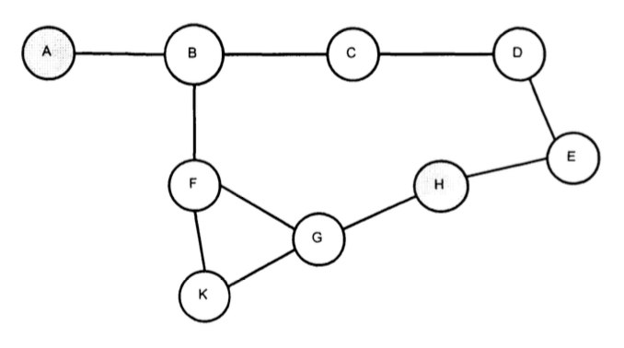

1. Describe and compare both Frequency Hopping Spread Spectrum and Direct Sequence Spread Spectrum.

For FHSS: Frequency hopping spread spectrum use M different carrier frequencies which are modulated by the source signal. During the process, a carrier frequency is selected at one time for every hopping according to the k-bit pattern which is generated by PN.

Carrier frequency hopping according to chips; potential frequency collision; faster hardware required.

For DSSS: Signals multiples by chips; near-far effect (when interfering transmitter get much closer to the receiver than the intended transmitter); require adoptive power control.

1. Give a description of the “hidden terminal problem” in a wireless LAN and explain how it can be solved. You should use diagrams that present a spatial arrangement of a few network transmitters to illustrate the problem.

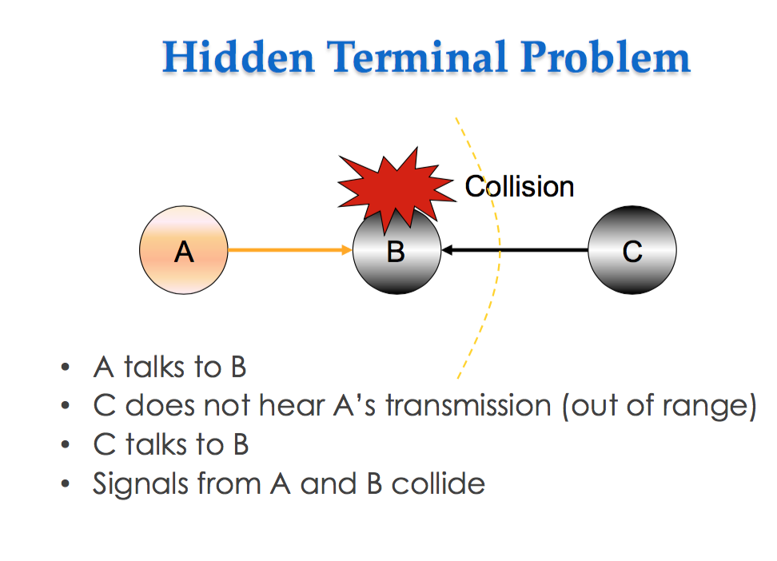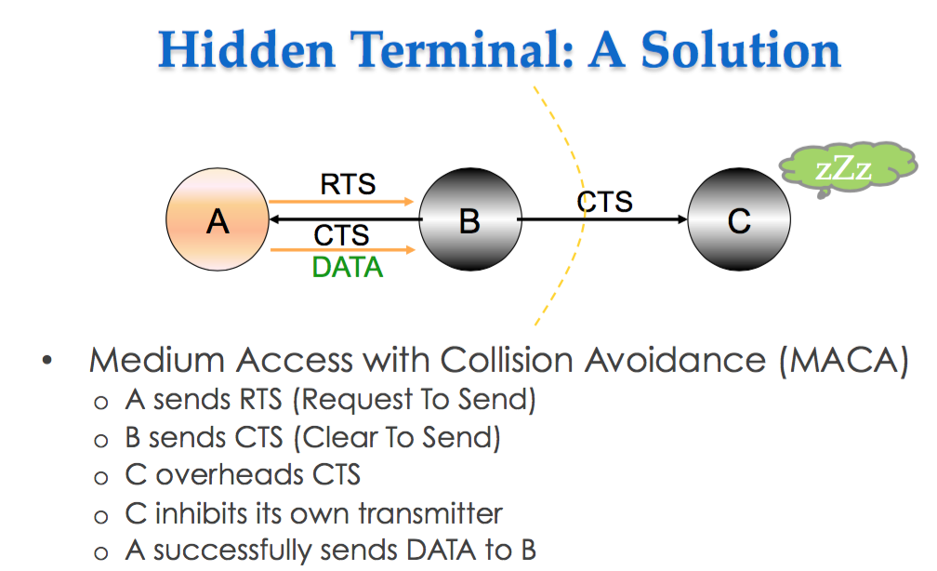

1. The figure below shows a scheme with multiple frequency-shift keying input encoding and pseudonoise (PN) sequence for Frequency Hopping Spread Spectrum (FHSS).
2. Is this an example of slow frequency hopping or fast frequency hopping, and why?

It is a fast frequency hopping, because the frequency hopping split each signal element across different hopping frequency.

1. 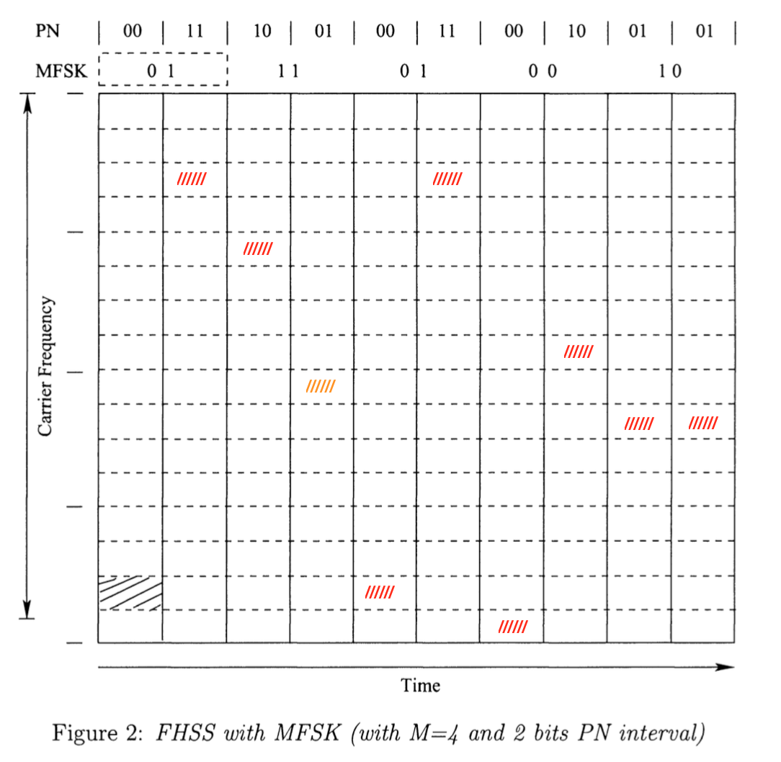
2. Name four type of impairments encounter by signal propagating in unguided media.
3. Attenuation and attenuation distortion
4. Noise
5. Atmospheric absorption
6. Multipath and refraction.
7. Briefly outline four common medium access control methods used in wireless communications.
8. Carrier sense multiple access / collision avoidance (CSMA/CA)
9. Frequency division multiple access (FDMA)
10. Time division multiple access (TDMA)
11. Code division multiple access (CDMA)
12. In a mobile ad hoc network:
13. Why is Dynamic Source Routing (DSR) vulnerable to fabrication attack?

Give an example.

1. How dose the source Routing Protocol (SRP) resolve this problem?
2. What is WiMAX and what kind of signal encoding does it employ? Give a brief description with diagram to explain how its signal encoding works?
3. Briefly describe both LEO and GEO, highlighting the differences between them in terms of orbit period, altitude, and round-trip delay; Under what circumstances would it be advantageous to select one of there satellite types (GEO and LEO) over the other?

For GEO: 24 hours a round, over 35000 km, round-trip delay is high.

For LEO: 1.5 to 2 hours a round, under 2000km, less than 20ms.

|  |  |  |
| --- | --- | --- |
|  | Advantages | Disadvantages |
| GEO | 1. No problem with frequency change. 2. Tracking of satellite is simplified. 3. High coverage of area | 1. Weak signal 2. Polar regions are poor served 3. Signal sending delay is substantial |
| LEO | 1. Less round trip delay | 1. Must cope with Doppler shift 2. Atmospheric drag results in orbital deterioration |

|  |  |
| --- | --- |
| GEO | LEO |
| usage | usage |

1. Explain the following two attacks to wireless sensor network (WSN) and suggest a possible solution:
2. Blackhole
3. Playback
4. Give a brief overview of the function of mobile IP. In this connection, mention the operation of the home agent and the foreign agent.
5. In a CDMA cellular system, what are the factors that make power control desirable?
6. Received power must be sufficiently above the background noise for effective communication.
7. Desirable minimize power in the transmitted signal from mobile.
8. Reduce co-channel interference, alleviate health concerns, save battery power
9. In SS systems using CDMA, it’s necessary to equalize the received power level from all mobile units at the BS.
10. Android offers several ways to realize your program. Please indicate their main differences and give example use cases that are recommended for each.

|  |  |  |
| --- | --- | --- |
| Web App | Android standard app | Android Native app |
| web application utilizing android SDK, apps reply on exist Web data,  Allows to build apps with interface to web content. Recommended to use when minimal logic required and data source is from the web. Not recommended when complex app logic is required. | Android App Standard: Java Application using android SDK, most android apps use this  Recommended for most Android application. For CPU intensive applications, we would consider using Android NDK (Native Apps). | Android Native Apps:  Java, C, C++ Apps using android SDK and NDK, development takes a lot of effort. used for CPU intensive applications such as physics and signal processing. Also useful when we have an existing C/C++ code base which we would like to implement in our Android app (e.g. we have built the same app in iOS and would to port over to Android) |

1. How does Android handle Activities that are currently not visible (they are stopped or paused) and how does Android avoid running out of memory?

Activities that are paused or stopped are handle by the activity stack, changing screens starting a new activity will push to current visible screen to the top of the stack. The other activities sit in the background paused or stopped until they are accessed again by going back through the stack. The system manages available memory and determines if new activities can be run.

Android avoids running out of memory by killing processes following a hierarchy of importance. The hierarchy, in order of least important to most important are empty processes, background processes (with activities which are stopped) , service processes (e.g. media player), visible processes (with activities which are paused) and Foreground processes (with visible, active activities)

1. The Android build process consists of two major steps: Compiling and Packaging, and Signing. Please explain the steps and program files involved when Compiling and Packaging.
2. How does Android resolve implicit Intent and why can this be a security issue when application components are started with implicit intents?
3. Briefly explain what the calls to “findViewById ()” and “setOnClickListener ()” do within the following code: 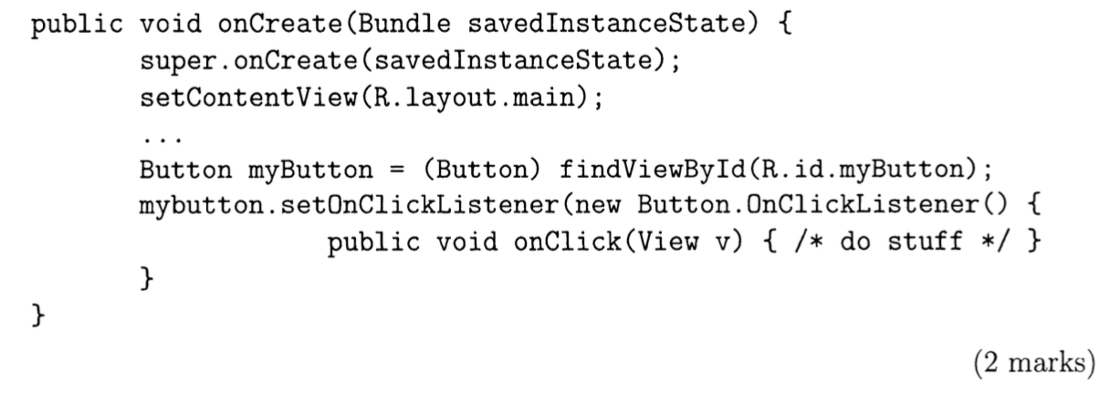
4. Explain the concept of “Fragments” in Android and why it was introduced?
5. What is the meaning of @ and + in the “android: id” tag? 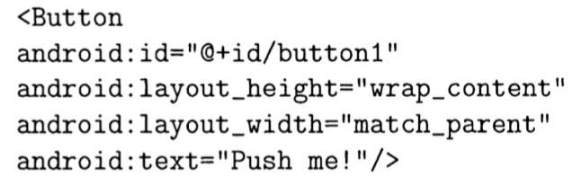
6. Explain the major contribution and idea of Assisted GPS (AGPS) and Differential GPS (DGPS) compare to traditional GPS.
7. When evaluating mobile application on can use qualitative or a quantitative approach. Describe the general idea and the drawbacks of each approach, and also give an example of when to use them?

## Android Part

Ubiquitous computing

several computing devices.

problem of android fragment

why do we use prototype?

Can show the process.

If you develop, you have multiple choices, what is your choices, the advantages of each?

A lot of questions about activity stack lifecycle!

what is it, its purpose, what is the idea behind it

How xml linked to activity, how does they linked, from java code to xml file to layout?

event handler, implicit intent, event filter

Thread in Android

Do not block UI thread

Do not touch UI component from thread outside the UI thread

Sensors

what is clock bias in GPS?

How GPS works

How to get distance? Why need 4 satellites, 3(x, y, z) + clock bias=4

Assisted GPS

what is the biggest advantage, start of time?

Real Time Kinematics GPS

if I can measure the phase, then I can improve the accuracy